**1.Header**

Example:



Content:

**We Set Rite** Vahn What-if V-all About Team Contact

Note:

Solid colours in the font . no gradients

**2.Middle**

Example:





Content:

**#WeSetRite.**

Adding values to your action

Note:

The content is left aligned. All the font colour is solid white except “set “ which must be in grey.

**3.About**

Content:

Who are we?

Are we an international company?

How long have we been established?

Note:

No major changes. Just change the questions like given above.

**4.Domains**

Example:

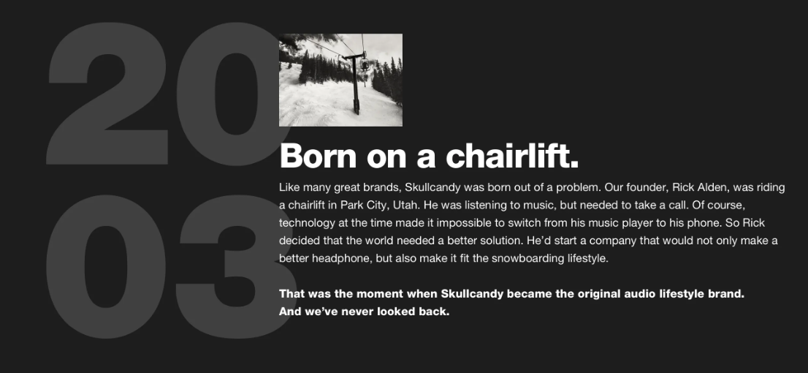

Content:

VAHN – Automotive Design and Engineering

The world of automotive has clearly categorised the user group. VAHN is a bold solution that works on creating impartial concepts that strike caution and responsibility at the same time. Our work is definitely conscious but we don’t compromise on alluring our customers.

WHAT IF – Product Design

WHAT IF endorse a loud vibe that says there can be meaning in a lot of chaos. We believe that every product today can be made with a special token to the environment. Monotony is not What If’s vibe!

VALL – Architecture Design

VALL is an open way of thinking that delineates today’s architecture and design environment and their cross interdependencies, cross-disciplinary and cross-cultural influences. Minimalism, Rationalism and climatic response is our significance. We aim at crafting every project as a one-off, tailor-made path.

Note:

The logo in the background. Same colour code as in example

**5.Teams**

Content:

Nishanth Nithyanandham - Managing director and founder

Linkedin-<https://www.linkedin.com/in/ing-nishanth-nithyanandham-7725b2136/>

Facebook-<https://www.facebook.com/nishanth.nt>

instagram-<https://www.instagram.com/nishanthnt/>

Akshatha Ravi Kumar - Director and co-founder

Linkedin- https://www.linkedin.com/in/akshatha-ravi-kumar-3a381419a/

Facebook- https://www.facebook.com/akshatha.rk

Instagram- <https://www.instagram.com/akshathark/>

ABHISHEK V NAIDU - Mentor

Linkedin- <https://www.linkedin.com/in/techevangelist/>

Pugazhendhi Kannan - Procurement Manager

Linkedin- http://linkedin.com/in/pugazhendhi-kannan-513a30167

Facebook-https://www.facebook.com/pugal.95

instagram-https://www.instagram.com/pugazhendhi_kannan/

##### Akshata Vadvadgi - Content developer and architect

Facebook- https://www.facebook.com/akshata.vadvadgi

Instagram- https://www.instagram.com/akshata_vadvadgi/

ARJUN CHETTIYATTIL PANKAJ - Business development and analyst

Linkedin- https://www.linkedin.com/in/arjun-chettiyattil-pankaj-88013397/

Facebook- https://m.facebook.com/arjun.cpankaj

Instagram- <https://www.instagram.com/arjun.c.pankaj/>

Venkatesh Sundarraman - Mechanical design and development engineer

Linkedin- https://www.linkedin.com/in/venkatesh-sundarraman

Facebook- https://www.facebook.com/venkatesh.sundarraman

Nikitha Nithyanandham - Research analyst (intern)

Linkedin-http://www.linkedin.com/in/nikithanithhi

Facebook- https://www.facebook.com/nikitha.nithhi

Instagram- https://www.instagram.com/nikitha_nithhi/

Preethi Mathialagan - Architect and Research analyst

Linkedin- https://www.linkedin.com/in/preethi-mathialagan-19021994/

Facebook- https://www.facebook.com/preethi.mathi/

Instagram- https://www.instagram.com/preethi_m94/?hl=en

Apeksha Ravi Kumar - Research analyst (intern)

Facebook- <https://www.facebook.com/apeksha.rk.5>

Instagram- <https://www.instagram.com/apeksha_ravikumar/>

Lakshmi Narayanan -

Linkedin-

Facebook-

Instagram-

**6.Contacts**

Note:

Same . as it is

**7.Page references**

[**https://www.skullcandy.eu/shop/earbuds/bluetooth-earbuds/indy-fuel**](https://www.skullcandy.eu/shop/earbuds/bluetooth-earbuds/indy-fuel)

[**https://www.skullcandy.eu/shop/earbuds/bluetooth-earbuds/indy**](https://www.skullcandy.eu/shop/earbuds/bluetooth-earbuds/indy)

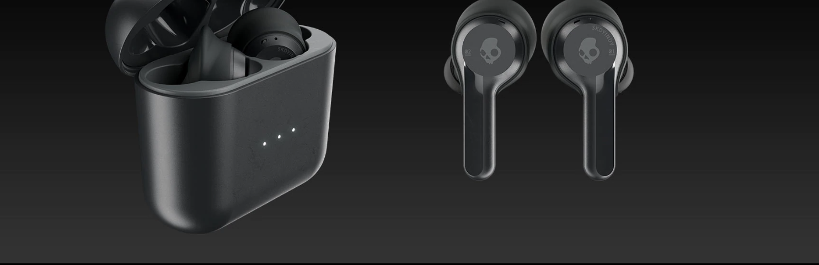

**(colour gradients like above)**